**GRAMMAR**

**ACTIVE AND PASSIVE VOICE**

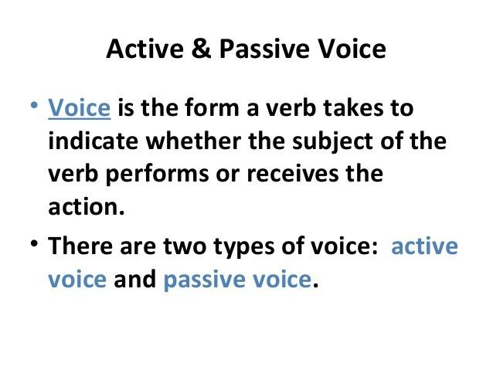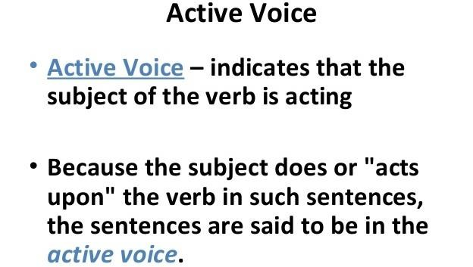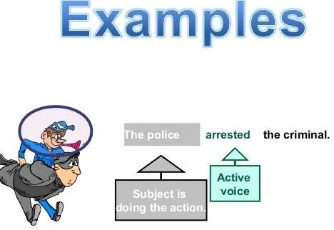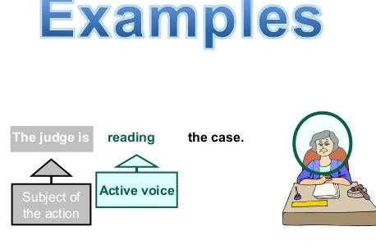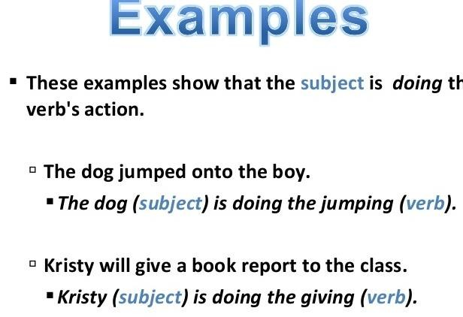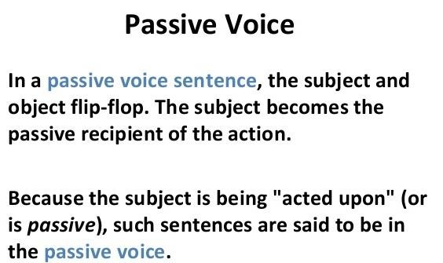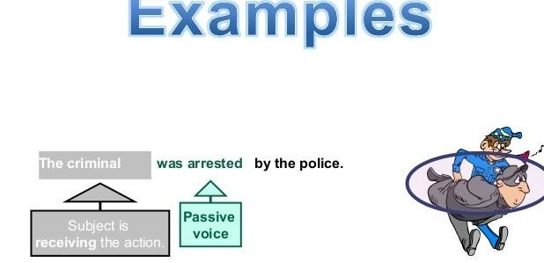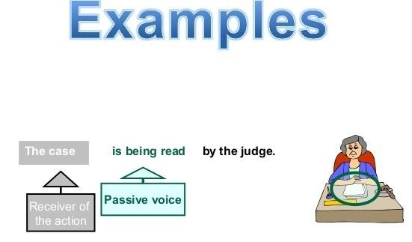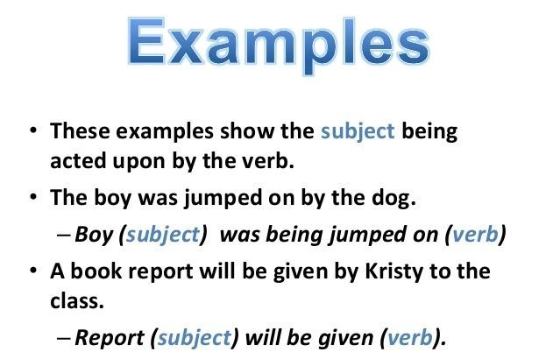

**RULES OF ACTIVE AND PASSIVE VOICE**

**Rule 1 :**

* **Simple Present Tense**

|  |  |
| --- | --- |
| **Active Sentences** | **Passive Sentences** |
|  |  |
| **He writes an essay** | **An essay is written by him** |
|  |  |
| **Sheena does the housework** | **The housework is done by Sheena** |
| **She cares for the rabbit** | **The rabbit is being cared for by her** |
|  |  |
| **Jacob always plays the guitar** | **The guitar is always played by Jacob** |

**Rule 2 :**

* **Present Continuous Tense**

|  |  |
| --- | --- |
| **Active Sentences** | **Passive Sentences** |
|  |  |
| **They are eating bananas** | **The bananas are being eaten by them** |
|  |  |
| **Bob is drawing a diagram** | **A diagram is being drawn by Bob** |
|  |  |
| **Samta is playing the piano** | **A piano is being played by Samta** |
|  |  |
| **She is waiting for Reema** | **Reema is being waited for by her** |

**Rule 3:**

* **Simple Past Tense**

|  |  |
| --- | --- |
| **Active Voice** | **Passive Voice** |
|  |  |
| **Ria paid the bills** | **The bills were paid by Ria** |
| **The teacher called the student** | **The student was called by the teacher** |
|  |  |
| **She did not buy the fruits** | **The fruits were not bought by her** |

**Rule 4:**

* **Past Progressive/Continuous Tense**

|  |  |
| --- | --- |
| **Active Voice** | **Passive Voice** |
|  |  |
| **They were waiting for him** | **He was being waited for by them** |
|  |  |
| **Astha was learning French** | **French was being learnt by Astha** |
| **She was playing kabaddi** | **Kabaddi was being played by her** |
|  |  |

**Rule 5:**

* **Past Perfect Tense**

|  |  |
| --- | --- |
| **Active Voice** | **Passive Voice** |
|  |  |
| **She won the match** | **The match had been won by her** |
|  |  |
| **I had finished her work** | **Her work had been finished by me** |
|  |  |
| **He had missed the last metro** | **The last metro had been missed by** |

**Rule 6:**

* **Simple Future Tense**

|  |  |
| --- | --- |
| **Active Voice** | **Passive Voice** |
|  |  |
| **He will write a letter** | **A letter will be written by him** |
|  |  |
| **He will repair her cycle** | **Her cycle will be repaired by him** |
|  |  |
| **He shall start the meeting** | **The meeting will be started by him** |

**Rule 7:**

* **Future Perfect Tense**

|  |  |
| --- | --- |
| **Active Voice** | **Passive Voice** |
|  |  |
| **Meena will not have changed the bedsheet** | **The bed sheet will not have been changed by**  **Meena** |
|  |  |
| **They will have won the match** | **The match will have been won by them** |
| **Reena will have washed the skirt** | **The skirt will have been washed by Reena** |

# ACTIVE AND PASSIVE VOICE

**CHANGE THE FOLLOWING SENTENCES INTO PASSIVE VOICE:**

1. **He teaches English.**

**ANS: - English is taught by him.**

1. **The child is eating bananas.**

**ANS: - Bananas are being eaten by the child.**

1. **She is writing a letter.**

**ANS: - A letter is being written by her.**

1. **The master punished the servant.**

**ANS: - The servant was punished by the master.**

1. **He was writing a book.**

**ANS: - A book was being written by him.**

1. **Who wrote this letter?**

**ANS: - By whom was this letter written?**

1. **Somebody cooks meal every day.**

**ANS: - Meal is cooked every day (by somebody).**

1. **He wore a blue shirt.**

**ANS: - A blue shirt was worn by him.**

1. **May God bless you with happiness!**

**ANS: - May you be blessed with happiness (by God)!**

1. **They are building a house.**

**ANS: A house is being built by them.**

1. **I have finished the job.**

**ANS: The job has been finished by me.**

1. **I sent the report yesterday.**

**ANS: - The report was sent by me yesterday.**

1. **She bought a diamond necklace.**

**ANS: - A diamond necklace was bought by her.**

1. **Somebody had stolen my purse.**

**ANS: - My purse had been stolen (by somebody).**

1. **The librarian arranged the books in the shelf.**

**ANS: - The books were arranged in the shelf by the librarian.**

1. **John collects money.**

**ANS: - Money is collected by John.**

1. **Anna opened the window**

**ANS: - The window was opened by Anna.**

1. **We have done our homework.**

**ANS: - Our homework has been done by us.**

**19.The Government is planning a new road near my house**

**ANS: - A new road is being planned near my house by the Government.**

1. **My grandfather built this house in 1943.**

**ANS: - This house was built by my grandfather in 1943.**

1. **Picasso was painting Guernica at that time.**

**ANS: - Guernica was being painted by Picasso at that time.**

1. **The cleaner has cleaned the office.**

**ANS: - The office has been cleaned by the cleaner.**

1. **He had written three books before 1867.**

**ANS: - Three books had been written by him before 1867.**

1. **By this time tomorrow we will have signed the deal.**

**ANS: - The deal will have been signed by this time tomorrow.**

1. **People speak Portuguese in Brazil.**

**ANS: - Portuguese is spoken in Brazil (by people).**

1. **Everybody loves Mr. Brown.**

**ANS: - Mr. Brown is loved by everybody.**

1. **The wolf ate the princess in the story.**

**ANS: - The princess was eaten by the wolf in the story.**

1. **Somebody has drunk all the milk!**

**ANS: - All the milk has been drunk (by somebody).**

1. **A workman will repair the computer tomorrow.**

**ANS: - The computer will be repaired tomorrow by a workman.**

1. **Somebody must have taken my wallet.**

**ANS: - My wallet must have been taken (by somebody).**

1. **Mother made a cake yesterday.**

**ANS: - A cake was made by mother yesterday.**

1. **I will never forget this experience.**

**ANS: - This experience will never be forgotten by me**

1. **Did she do her duty?**

**ANS: - Was her duty done by her?**

1. **Have you finished the report?**

**ANS: - Has the report been finished by you?**

**CHANGE INTO ACTIVE VOICE:**

* 1. **The jar is filled with sand.**

**ANS: - Sand fills the jar.**

* 1. **The thief is being interrogated by the police.**

**ANS: - The police are interrogating the thief.**

* 1. **Reading is enjoyed by Mary.**

**ANS: - Mary enjoys reading.**

* 1. **The house has been decorated by my mother.**

**ANS: - My mother has decorated the house.**

* 1. **The town was destroyed by fire.**

**ANS: - Fire destroyed the town.**

* 1. **The matches have been cancelled by the board.**

**ANS: - The board has cancelled the matches.**

* 1. **The airplane was flown to Bermuda by the pilot**

**ANS: - The pilot flew the airplane to Bermuda.**

* 1. **You are requested to be quiet.**

**ANS: - Please be quiet.**

**9. Crackers were eaten by the puppy.**

**ANS: - The puppy ate the crackers.**

**10. The clothes are designed by the famous designer.**

**ANS: - The famous designer designs the clothes.**

**11. The thief had been caught by the police.**

**ANS: - The police had caught the thief.**

**12. The cheese was eaten by Sara.**

**ANS: - Sara ate the cheese.**

**13. I have been invited to their party.**

**ANS: - They have invited me to their party.**

**14. The dog was beaten by its master.**

**ANS: - Its master beat the dog**

**15. The flowers have been plucked by the children.**

**ANS: - The children have plucked the flowers.**

**16. Short stories are written by her.**

**ANS: - She writes short stories.**

**SOME ADDITIONAL SENTENCES:**

* 1. Active: Carry it home. 4. Active: Throw the ball. Passive: Let it be carried home Passive: Let the ball be thrown.
  2. Active: Do it at once. 5. Active: Help me. Passive: Let it be done at once. Passive: You are requested to help me.
  3. Active: Open the door. 6. Active voice: Who wrote this book?

Passive: Let the door be opened. Passive voice**: By whom** was this book written?